**HOW TO GUIDE**

**NEW MEMBERSHIP REGISTRATION**

**THROUGH SLSA MEMBERS PORTAL**

**All children under the age of 15 need a parent to join**

* Go to members.slsc.com.au

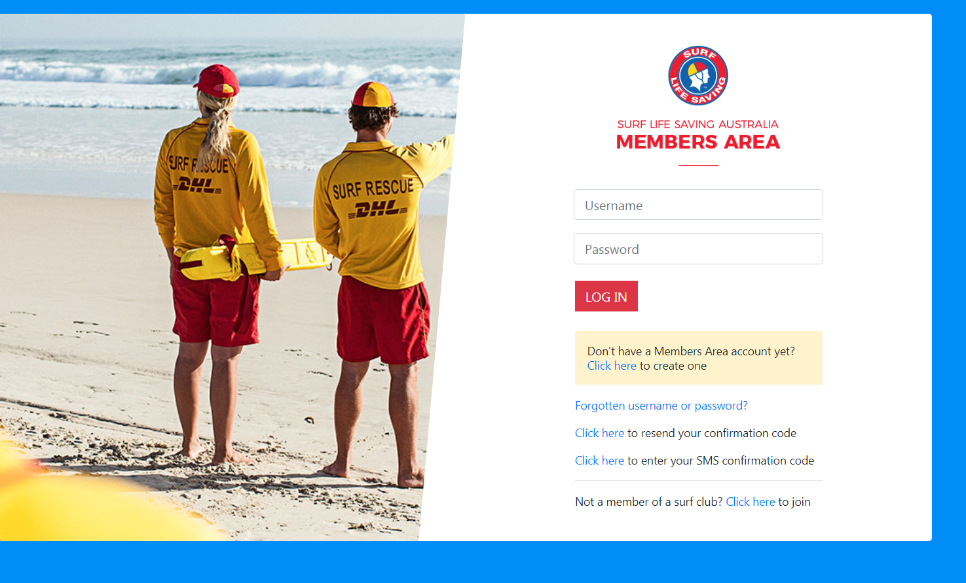

* Click on the bottom line – **Not a member of a surf club? Click here to join**

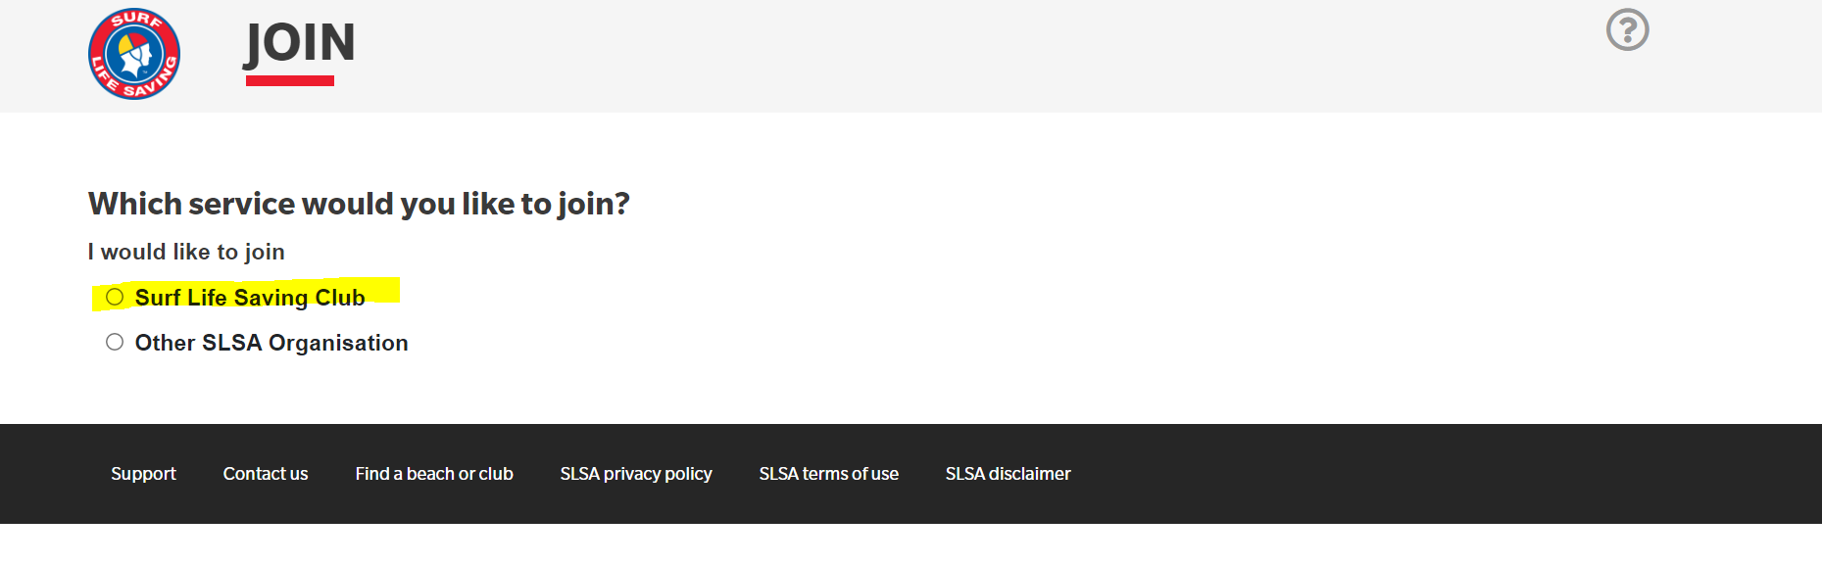

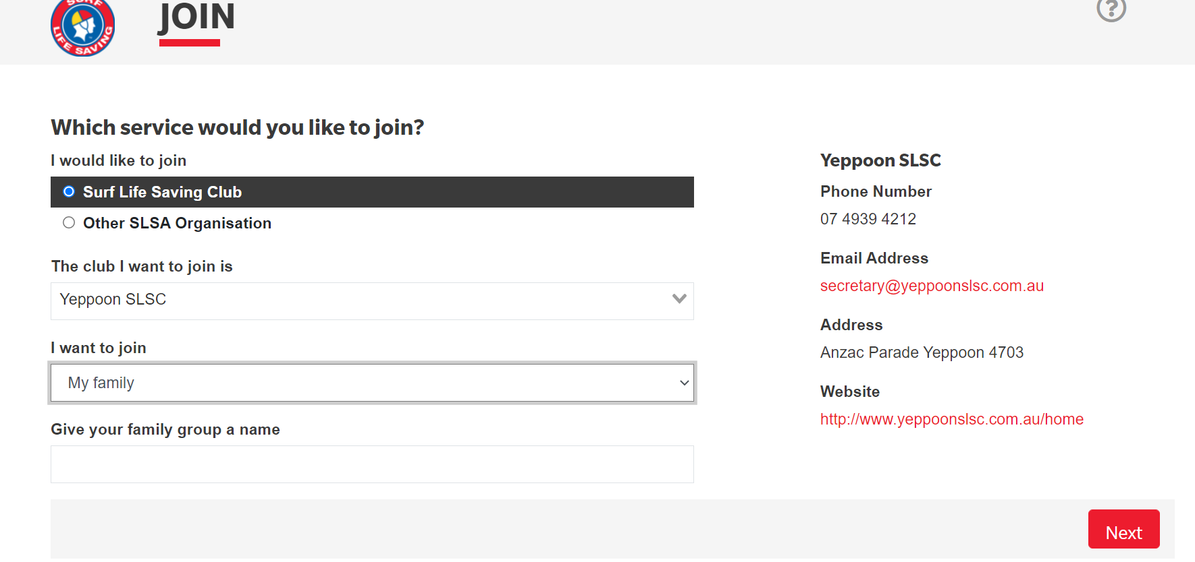

Adding Members to Family Membership

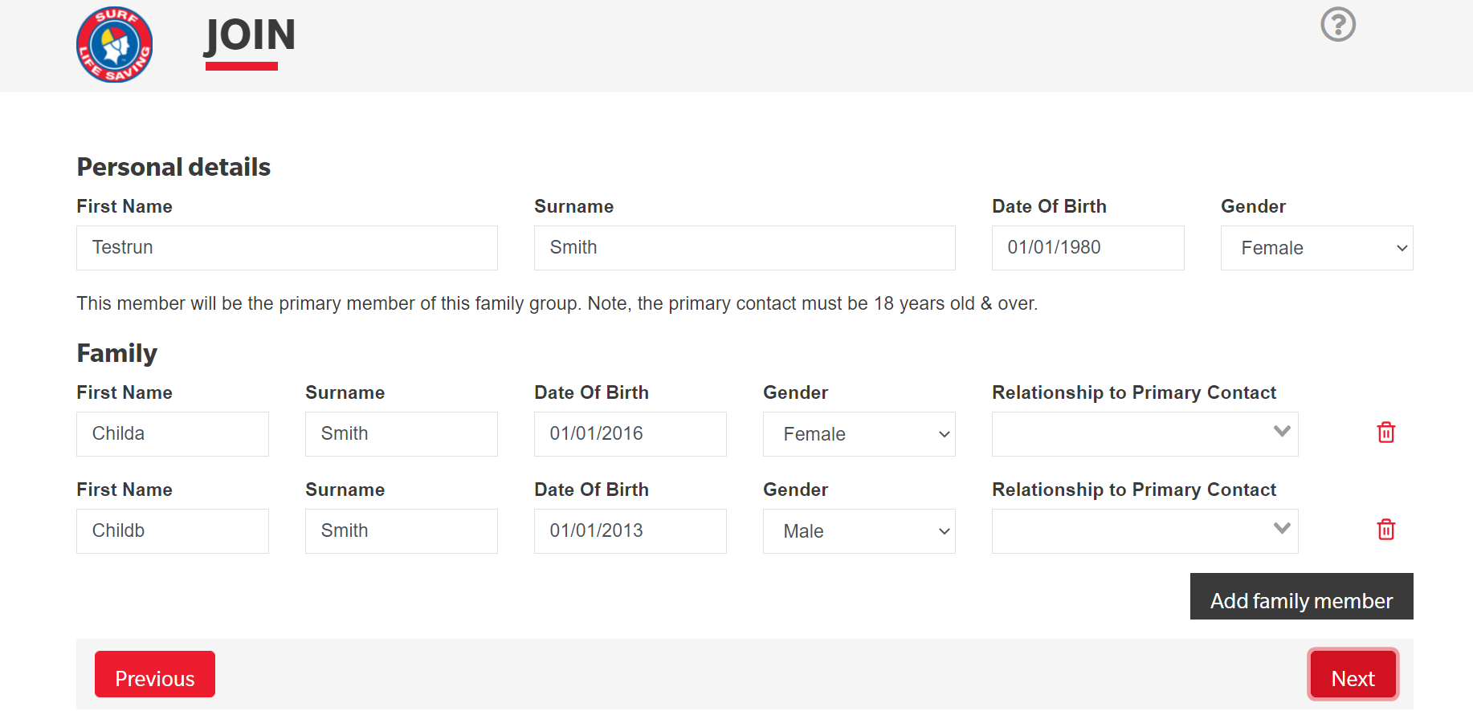

Provide your contact information

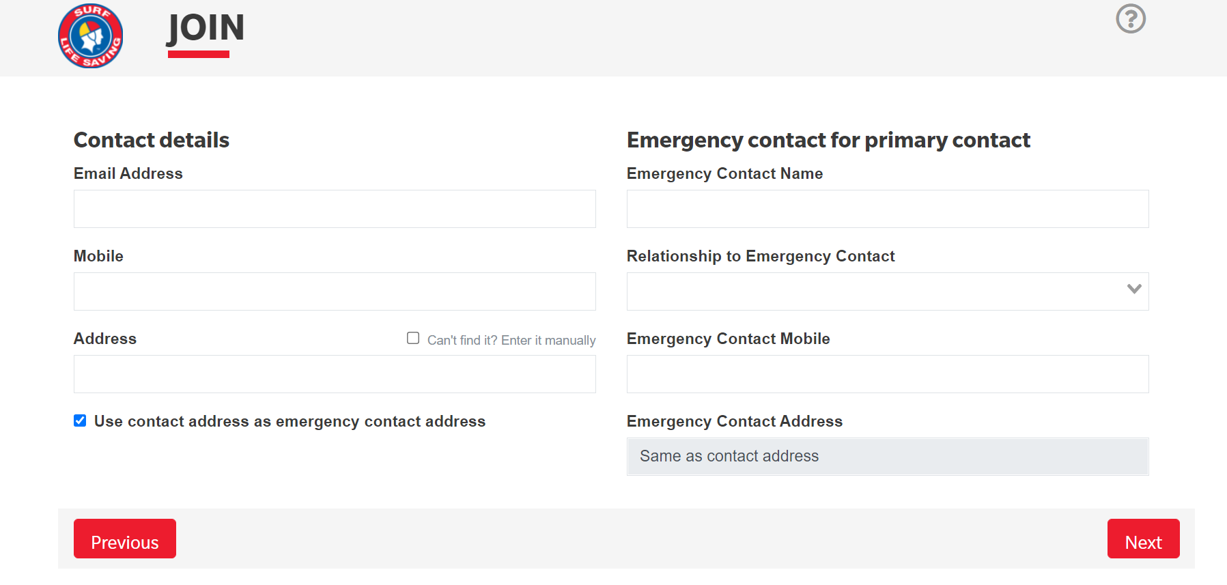

Provide your contact and Emergency contacts

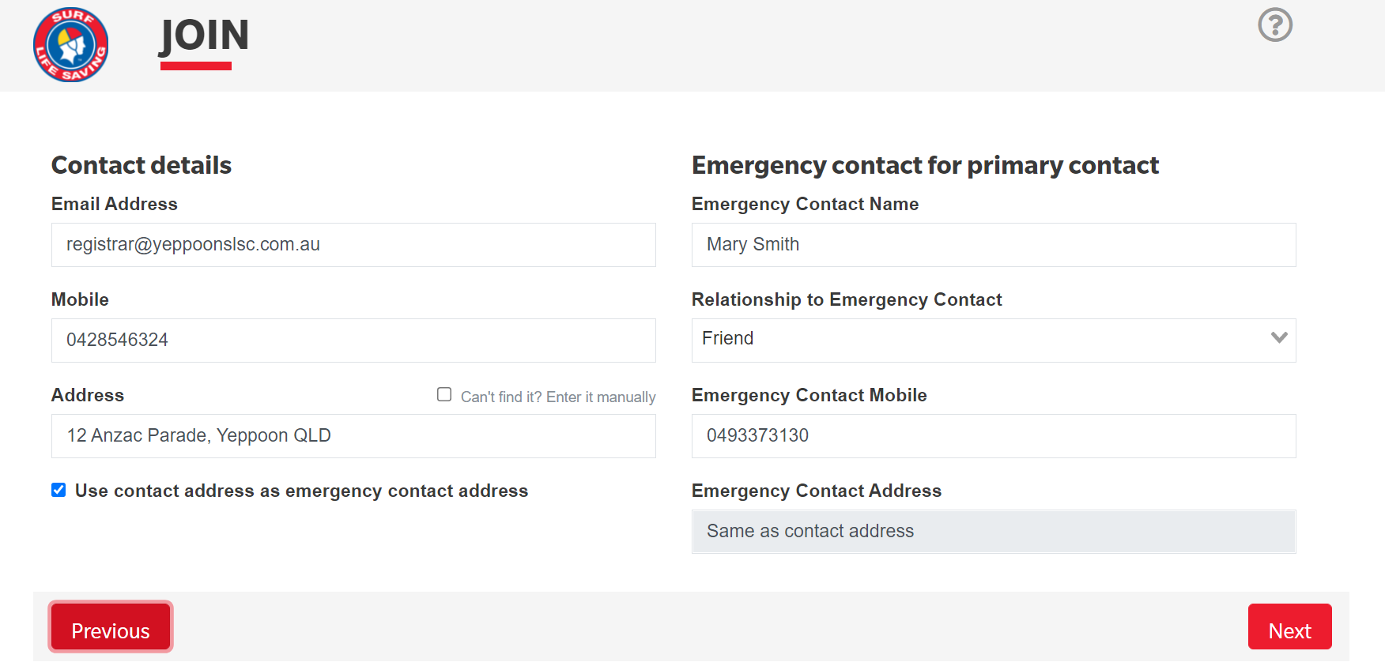

Check your infomration, create login and password and complete application declaration

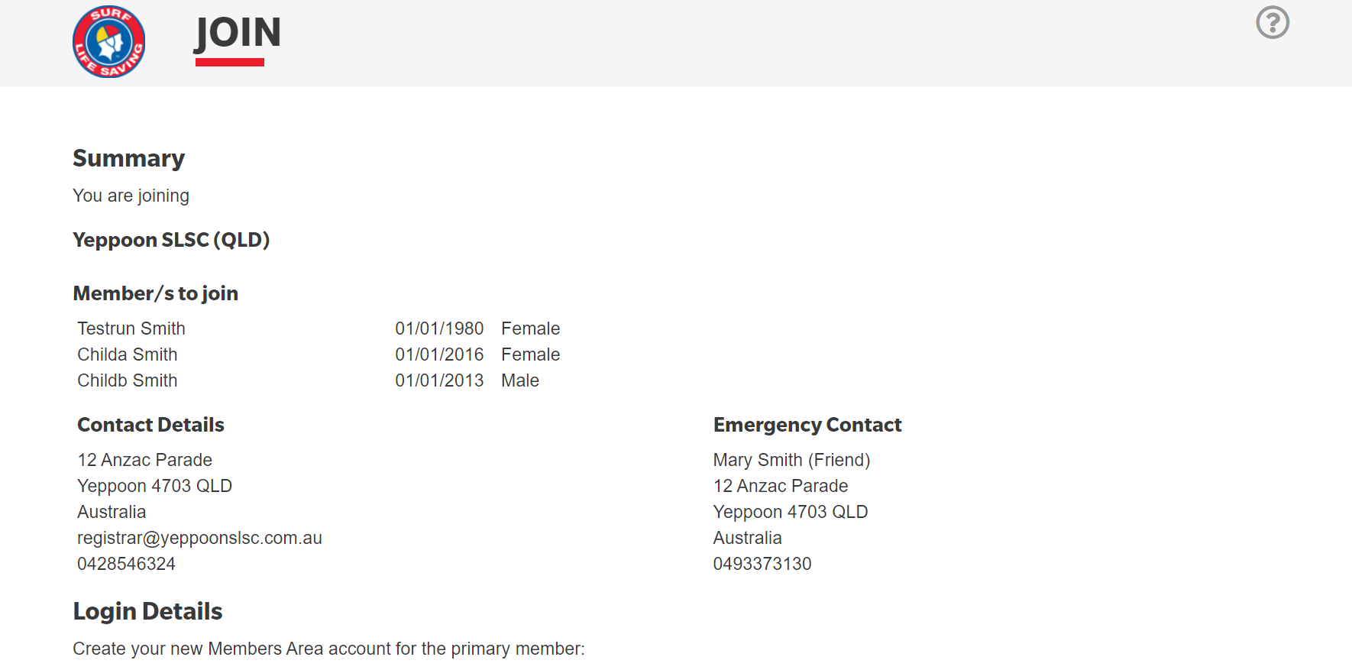

**Example**

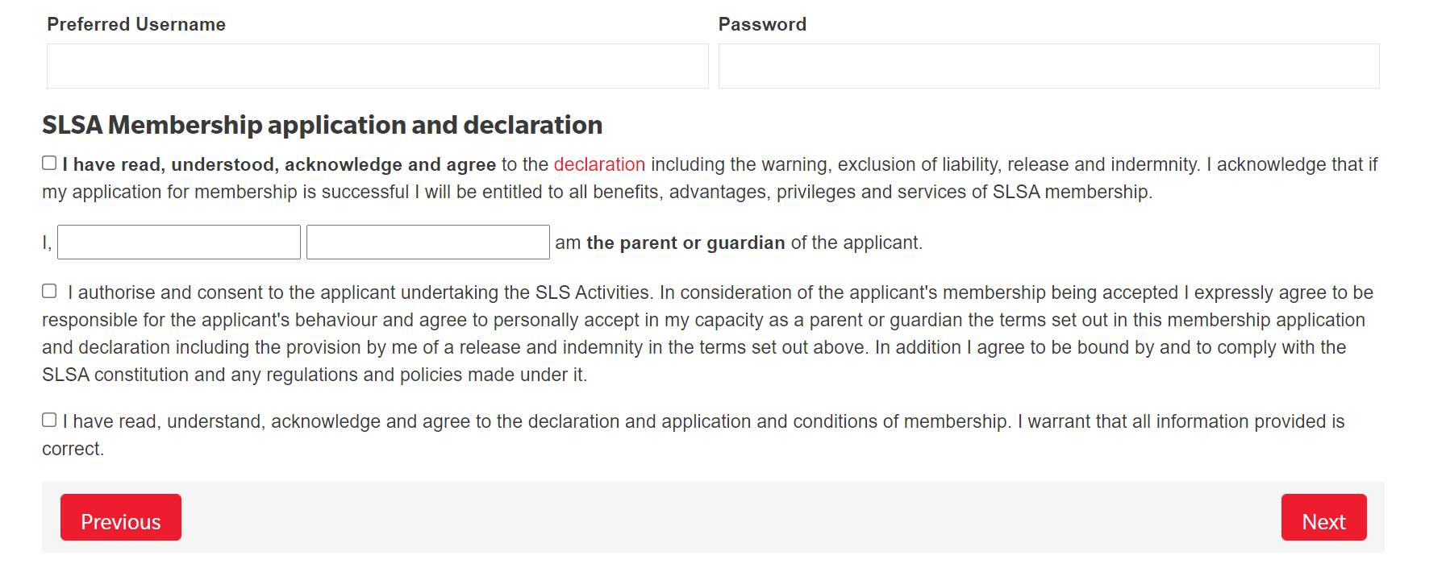

Hit Next to submit your application

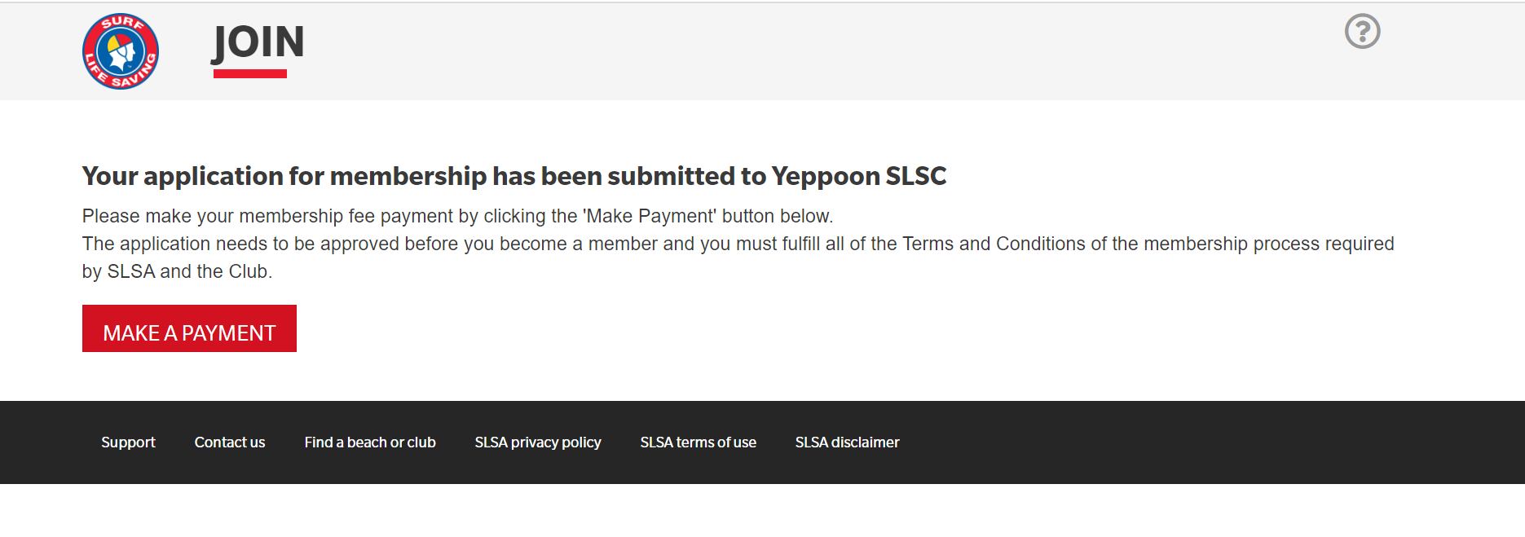

NEXT STEPS….

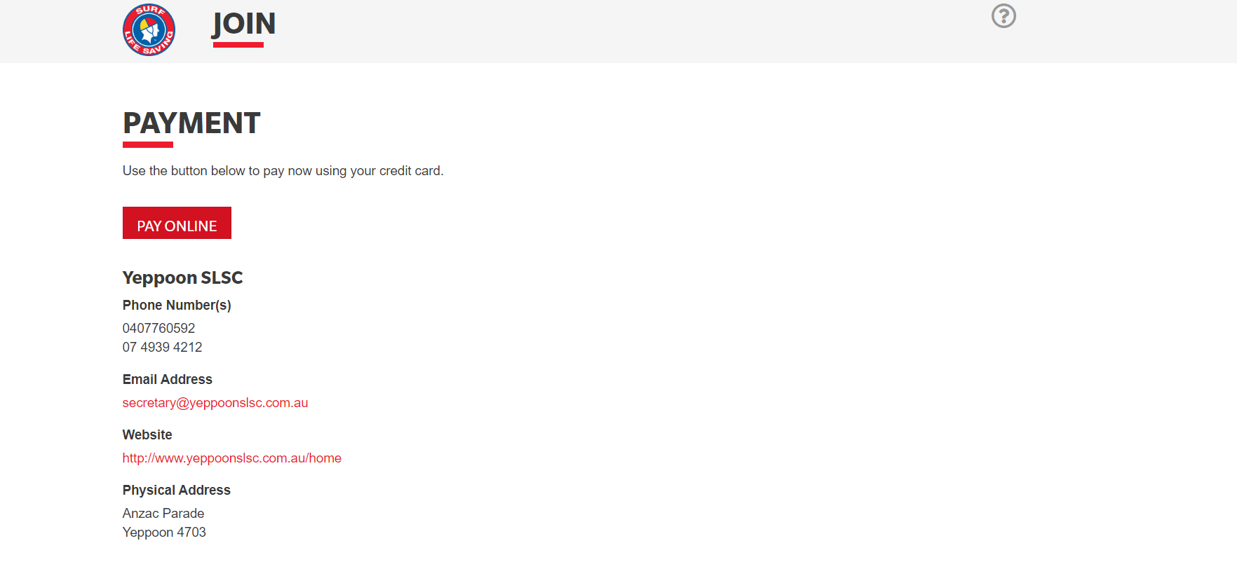

SELECT PAY ONLINE

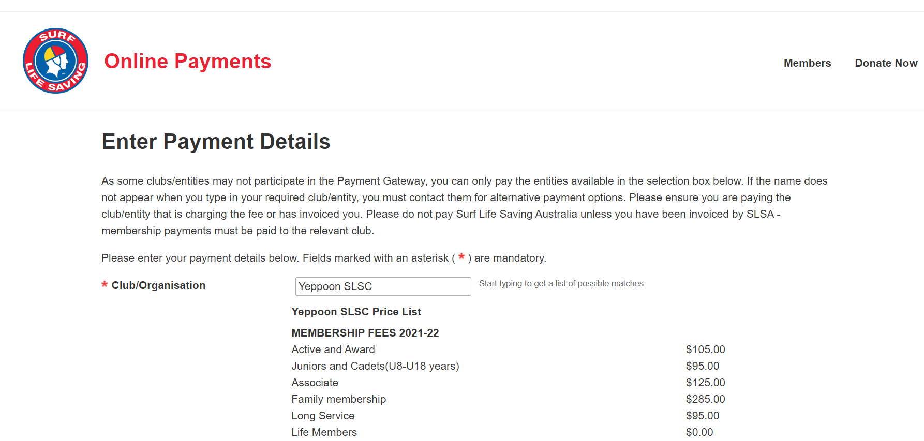

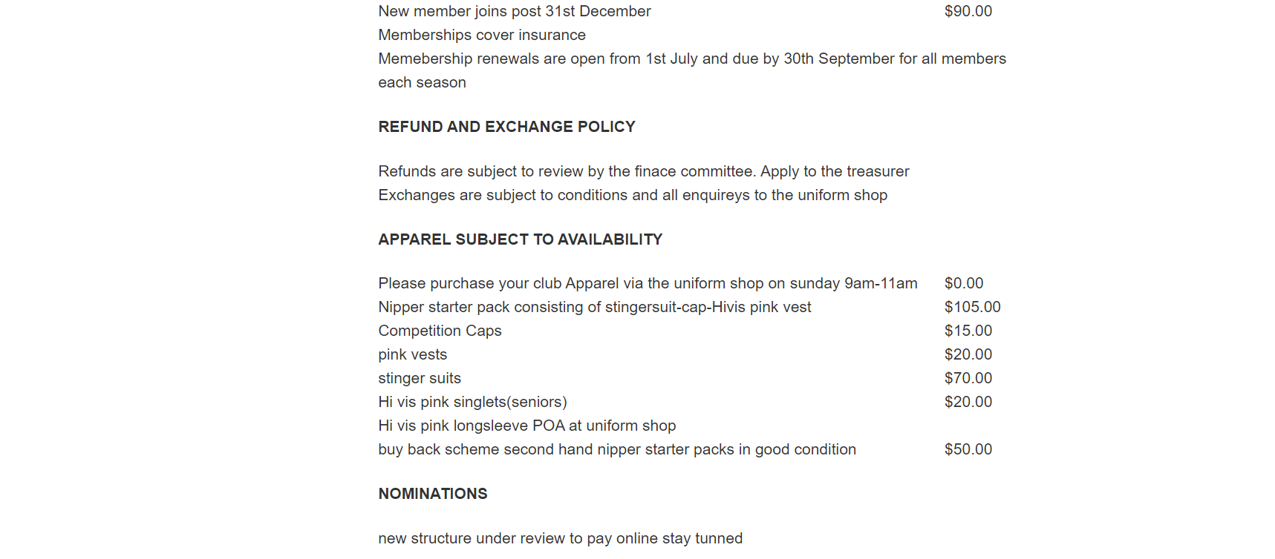

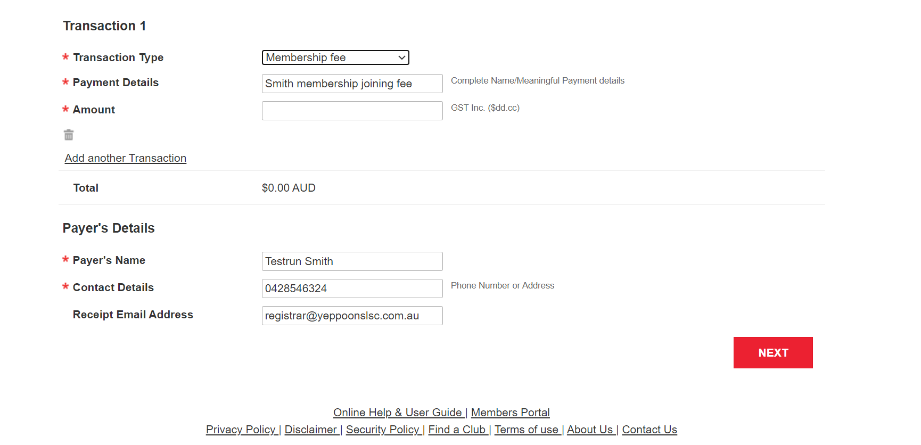

**Membership Fees 2020 -2021 Season**

|  |  |
| --- | --- |
| **Junior & Cadets**  Minimum age is 5 before 30th September 2021 | **$95** |
| **Award/Active Member**  Helps at Club with Junior Program and or wishes to undertake training | **$105** |
| **Associate Member**  Parent and non-active | **$125** |
| **Family Membership**  For up to 2 Parents and Junior/Cadets Members in same family unit | **$285** |

***For all membership queries please contact*** [***registrar@yeppoonslsc.com.au***](mailto:registrar@yeppoonslsc.com.au)

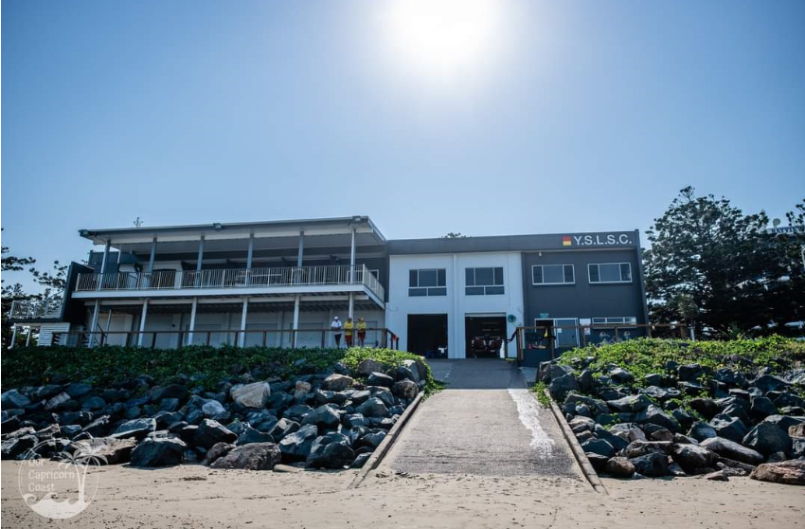

**Linda Hovey**

**Registrar**

**Yeppoon Surf Life Saving Club**





**About our Club**

The Yeppoon SLSC was established in 1926 and we have been a permanent fixed on the Yeppoon foreshore for almost 100 years.

Our junior program is designed for the whole family to be involved. Nippers is a great way for kids to not only to learn how to identify dangers on the beach and in the surf but also how to stay safe when they are at the beach. Nippers are the lifesavers of the future.

​

The minimum age for a child to join nippers is 5 years (U6) up to a maximum of 13 years (U14). The age for the season is determined as of midnight on the 30 September at the commencement of that season.

​

Nippers is on a Sunday morning from 9am – 11am.

These sessions are all dependent on water safety, weather conditions, program, etc, with a break over the Christmas holidays.

Nipper events include wades, board paddling, swimming, beach sprints and beach flags.  
Our "Greenies" (U6s and U7s) focus on fun and games on the beach which teach the children basic skills and awareness of where to swim and what help is available from the lifesavers.

​

U8 - U14 Nippers can also compete in local carnivals several times during the season and we encourage children to do so (to test their skills in a new beach environment and enjoy representing their team) ***but this is not compulsory***.

​

All of our Nipper Age Managers, Water Safety and Coaches, are all volunteers and are extremely qualified lifesavers themselves, so they teach based on their experiences across patrolling, competing and just enjoying the surf.

Assistance is always required with the beach set-up and pack down and the fundraising BBQ, which is manned by the parents of a different age group each week.

​

**Message from the President**

FAQs



### 

### **When is Nippers?**

Sunday 9am – 11am

The season commences on Sunday 3rd October 2021 and runs until March 2022 with end of season celebrations to be advised.

A Nippers calendar is available for you to plan your summer. At Yeppoon we are heavily influenced by tides and on occasion a Nippers day/time may change. Surf Life Saving Carnivals also impacts our volunteer base so ensure you keep up to date on any changes please refer to your calendar and seek advice from your Age manager or Junior Activities Coordinator.

**What if I can’t attend a Nipper Day?**

Sometimes life gets busy and or you Nipper may be unwell to attend. That is completely fine but please note regular attendance is important if you wish to represent the club at Surf Life Savings Carnivals and also complete their life saving proficiencies.

**What Uniform is Required?**

* Club Stinger Suit
* Pink Vest
* Club Hat or Green Cap

All your uniform needs can eb found at the Club House uniform shop. This is a volunteer shop and is open on Nippers days only. Volunteer if you can man to store.

### **Can I drop my child at Nippers and leave the beach and come back at the end to pick them up?**

No. It is a requirement of participation in the program that a parent or caregiver is on the beach at all times while their child is signed on at Nippers. It is an expectation that parents get involved in helping at Nippers each week, whether it is as a water safety officer, helping set up or cook the BBQ or assisting with beach set up/pack down.

Without parent helpers Nippers cannot run.

### ***My child can’t swim very well, is Nippers a good place for them to learn?***

**No**, Nippers is not a learn-to-swim organisation. Your child needs some reasonable swimming skills to be able to take part in Nippers each week. We recommend that you enrol your child in a swim school to learn basic swimming skills prior to joining Nippers. To participate in both beach and waer activities all junior nippers must complete swimming proficiencies.

### **My child is a current Nipper, do they still need to complete the pool and run/swim/run competency?**

Yes. Each year every child must complete the relevant Pool and Beach evaluations of their age group to participate in the program.

### **What is the expectation for Family Membership & Bluecards?**

At least one parent/carer must be a member of the Surf Club. The membership fees will cover two parents. Parents/Caregivers must also hold a volunteer Bluecard. This is essential for you participate in club events.

### **My Child’s Grandparent, nanny or other caregiver will sometimes bring them down to Nippers do they have to join?**

Yes they should be members to attend any club related activities.

If you are a single parent family you can join up a grandparent, nanny or other caregiver as part of your family membership at no additional charge (family membership structure includes up to 2 parents/guardians/caregivers). If you wish to sign up an additional (i.e. third) adult family member or carer this will be at an additional cost.

